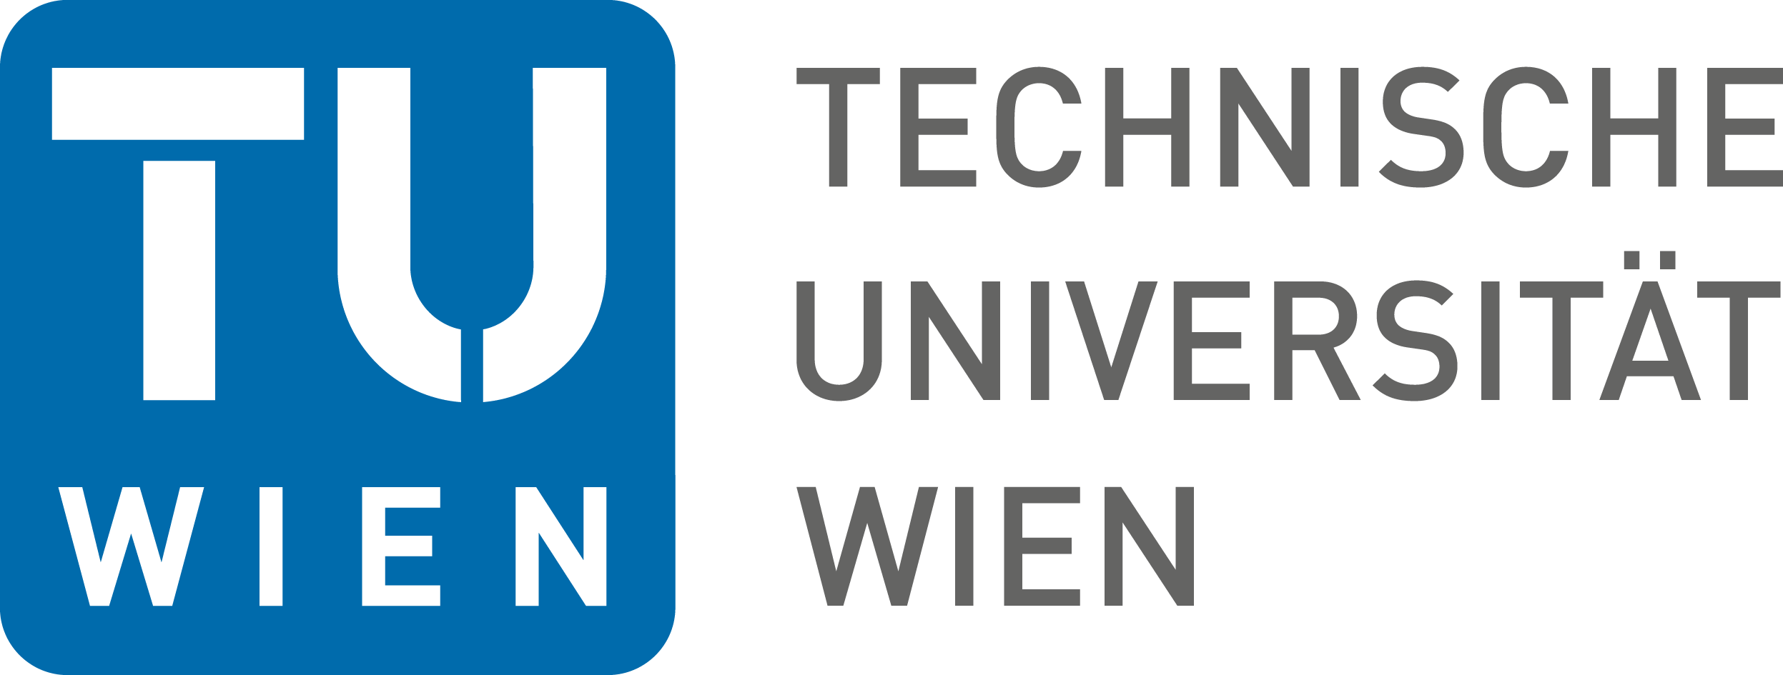

Announcement of an Opening at
the Institute of Solid State Physics, Faculty of Physics and
the Center for Transmission Electron Microscopy,
Technische Universität Wien

Assistant Professorship (Tenure Track)
Electron Microscopy for Materials Characterization

The Faculty of Physics invites applications for an Assistant Professorship (tenure track) in Electron Microscopy for Materials Characterization, with focus on electron energy loss spectroscopy. Synergies with the ongoing experimental research activities at the Institute of Solid State Physics (www.ifp.tuwien.ac.at) and the Center for Transmission Electron Microscopy (www.ustem.tuwien.ac.at) are required. The successful candidate is expected to be an internationally recognized scientist with a PhD in solid state physics or a closely related field, and an excellent track record. He/She should show hands-on experience in transmission electron microscopy and a profound theoretical basis in electron-matter interactions.

The candidate should contribute to teaching, after a transition period also in German.

The initial appointment is for 6 years with the possibility of promotion to a permanent position as Associate Professor following a positive tenure track evaluation. Entry level salary as a postdoctoral researcher is covered by grade B1 of the Austrian Collective Agreement for university staff, and receives a minimum of currently EUR 49.644,00 per year. After a positive tenure evaluation, this will be upgraded to grade A2, with a current minimum salary of EUR 58.709,00 per year.

The Technische Universität Wien is committed to increase female employment in leading scientist positions. Qualified female applicants are expressly encouraged to apply and will be given preference when equally qualified. Handicapped persons with appropriate qualifications are expressly encouraged to apply.

Applications including a detailed curriculum vitae, a list of publications, invited lectures, extramural funding and teaching records if applicable, copies of the five most outstanding publications, and a research plan detailing synergies with the two above research units should be sent to Technische Universität Wien, Fachbereich für wissenschaftliches Personal, Karlsplatz 13, 1040 Wien, Austria. Online applications (by a single pdf-file) should be sent to Ms. Ildiko Haidenschuster (ildiko.haidenschuster@tuwien.ac.at). Hardcopy applications must include a CD-ROM (or an USB stick) containing the entire application file.
Deadline for applications: December 2, 2015.

